Task 2: Phishing Simulation Report

1. Objective
The objective of this task is to simulate a phishing attack using the Social Engineering Toolkit (SET) in a controlled lab environment, in order to demonstrate how attackers can capture user credentials through deceptive web interfaces.

2. Tools Used
• Kali Linux
• Social Engineering Toolkit (SET)
• Web Browser (Firefox)

3. Methodology and Execution
The phishing simulation was carried out using SET’s Credential Harvester module. A predefined Google login template was used to create a fake login page hosted locally, and user credentials were captured upon submission.

Step 1
SET tool is launched, displaying the main interface used to initiate various social engineering attacks.
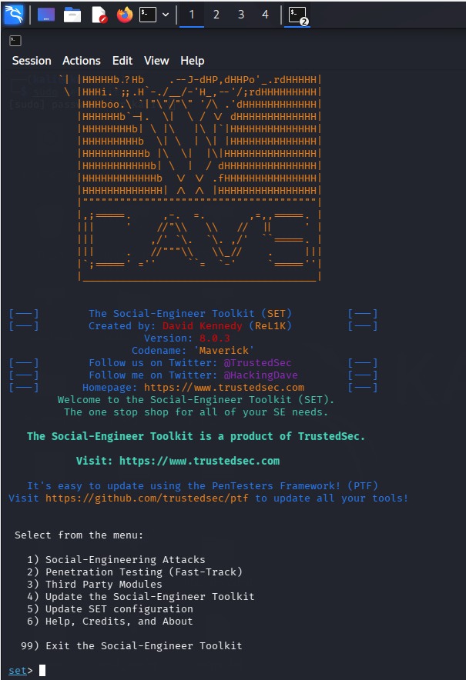

Step 2
The 'Social Engineering Attacks' option is selected to begin the attack workflow.
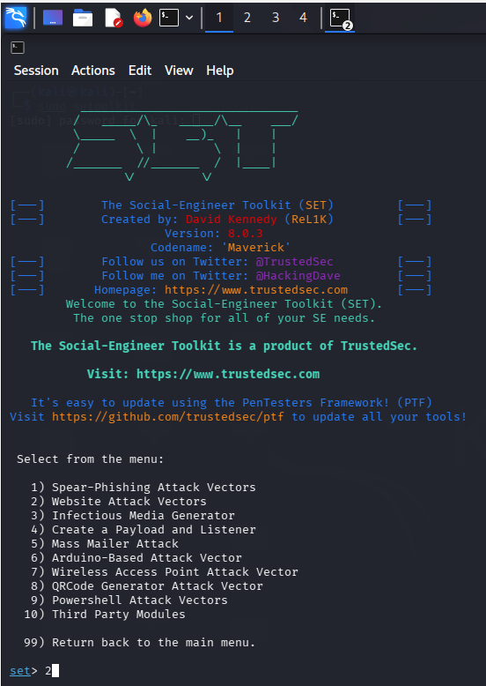

Step 3
The 'Website Attack Vectors' option is chosen to perform web-based phishing.
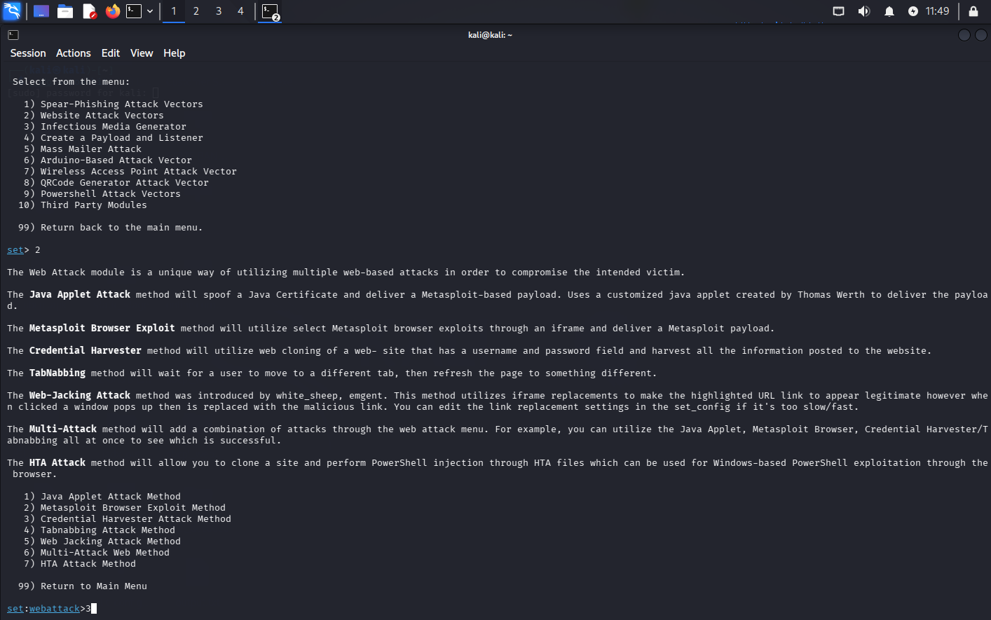

Step 4
The 'Credential Harvester Attack Method' is selected to capture user inputs.
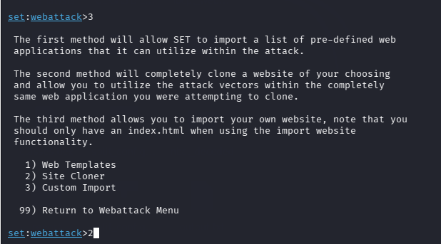

Step 5
The 'Web Templates' option is chosen to use a predefined phishing page.
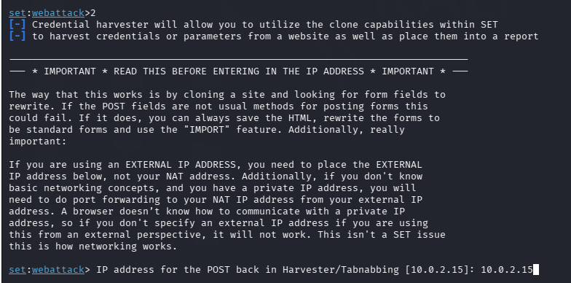

Step 6
The system prompts for IP configuration, which will be used to host the phishing page.
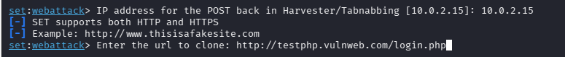

Step 7
The target URL setup begins as part of the phishing configuration.
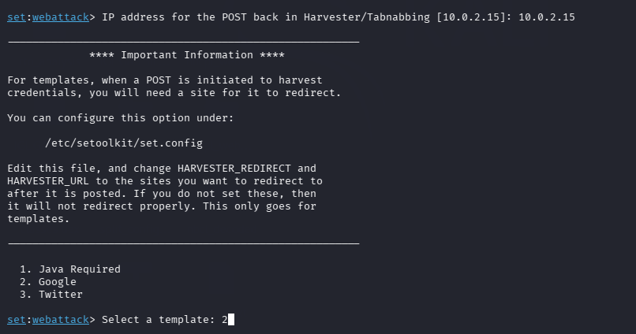

Step 8
The Google login template is selected for realistic phishing simulation.
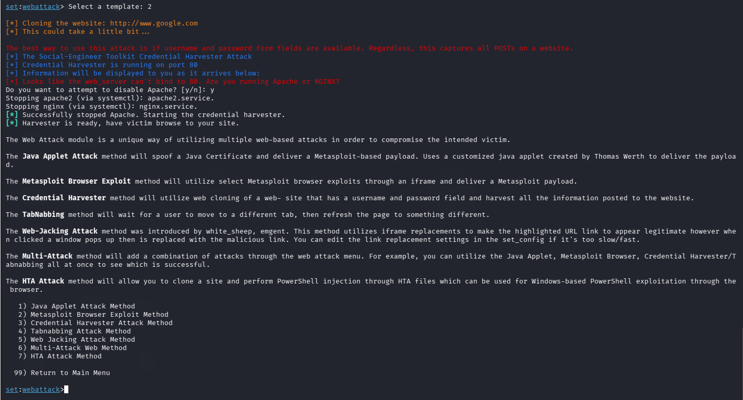

Step 9
The phishing server starts successfully and begins listening for incoming connections.
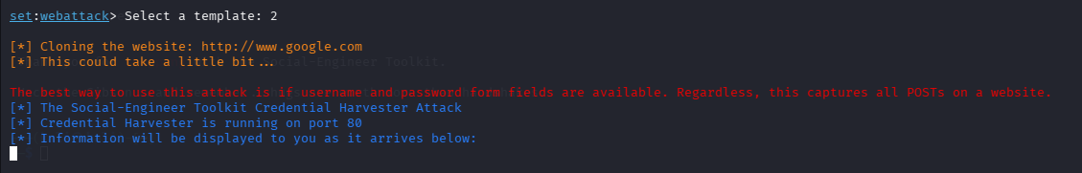

Step 10
A fake Google login page is displayed to simulate the victim interface.
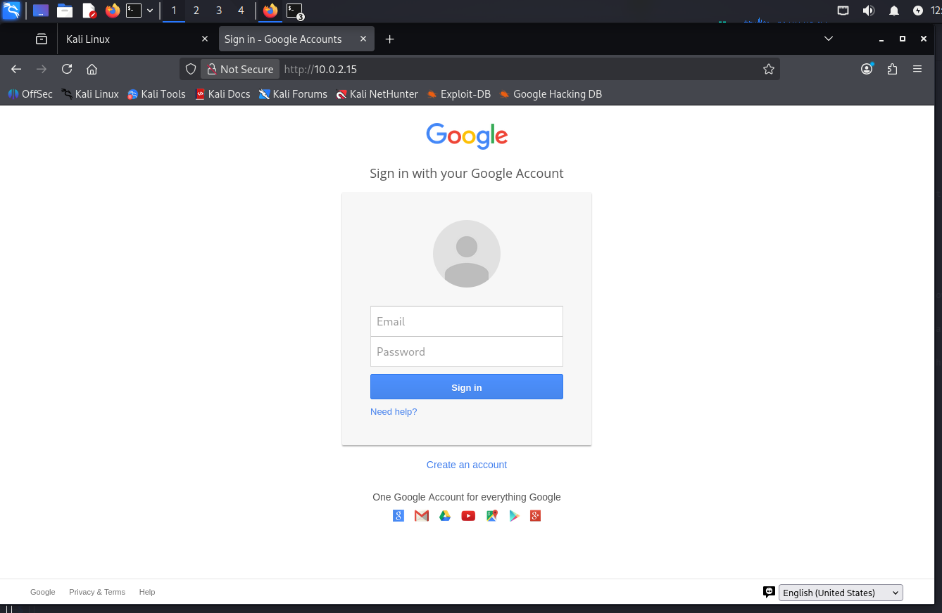

Step 11
Test credentials are entered into the phishing page to simulate victim interaction.
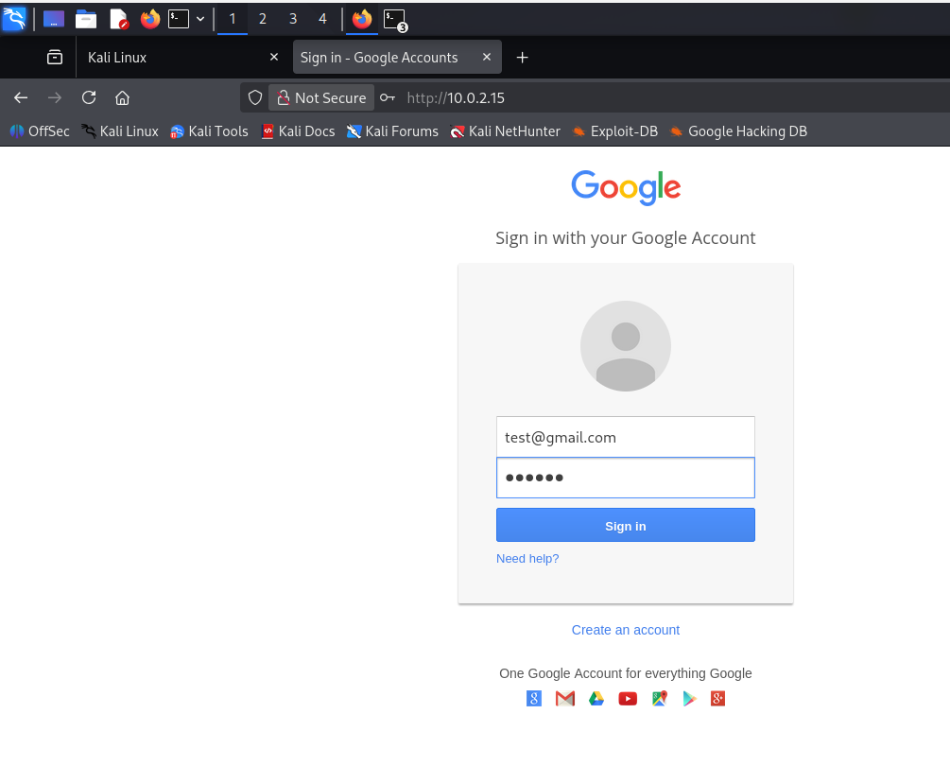

Step 12
After submission, the user is redirected to the legitimate Google page to avoid suspicion.
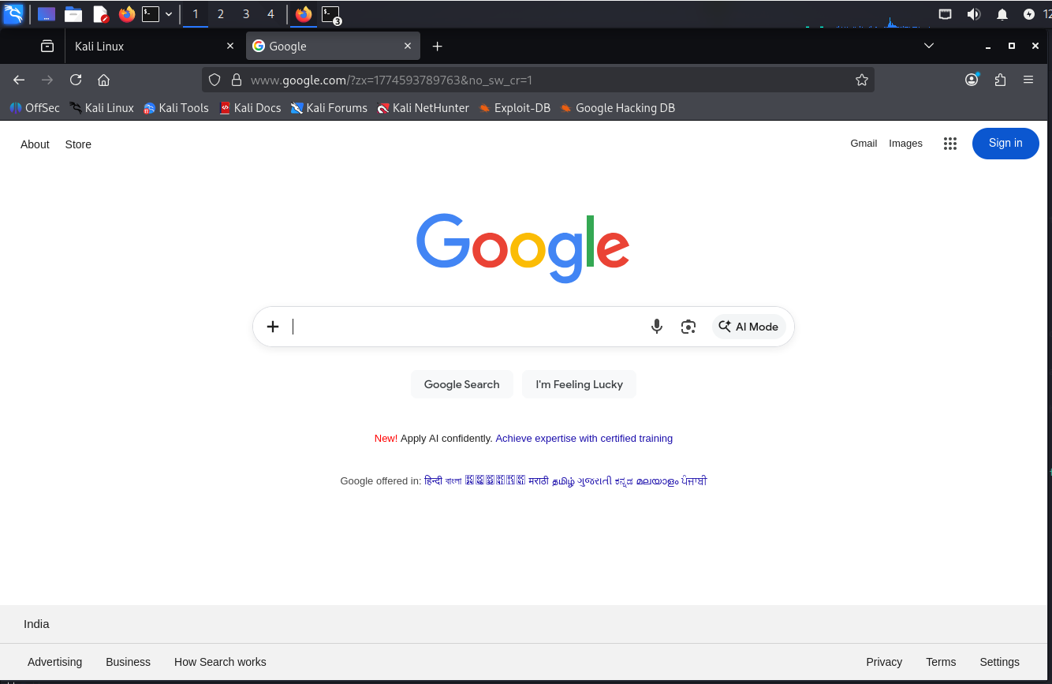

Step 13
The captured credentials are displayed in the terminal, confirming successful credential harvesting.
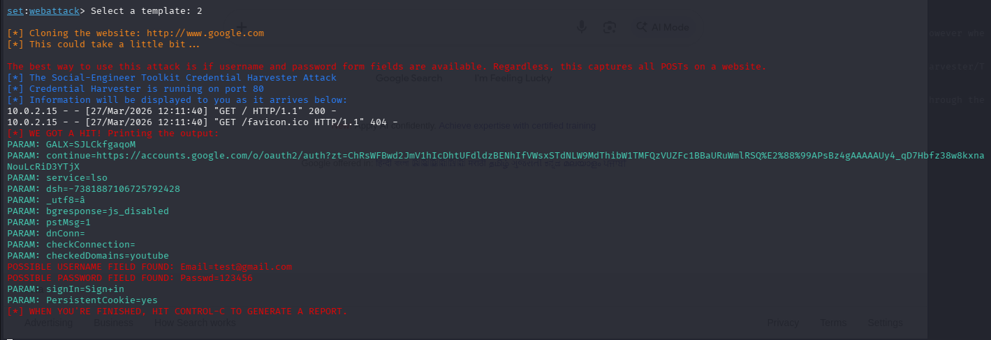

4. Result
The phishing simulation successfully captured user credentials (email and password) entered on the fake login page. This confirms the effectiveness of credential harvesting attacks in deceiving users.

5. Analysis
This simulation demonstrates that users can be easily tricked into entering sensitive information on fake websites that closely resemble legitimate platforms. Attackers exploit trust and visual similarity to achieve this.

6. Conclusion
The task highlights the importance of cybersecurity awareness, user education, and the implementation of security controls such as multi-factor authentication (MFA) and URL verification to prevent phishing attacks.

